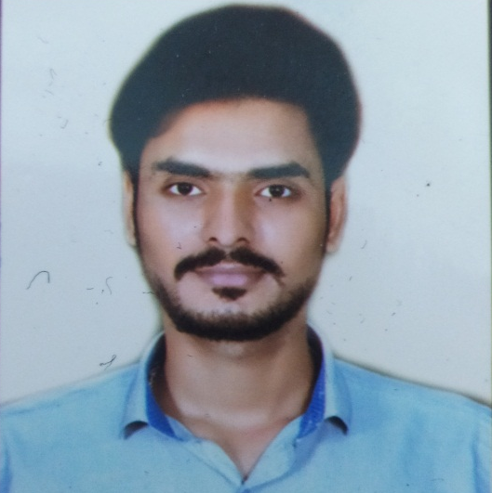
Vinay Chouhan
-> 9300884123 -> vinaychouhan288@gmail.com

Carrier Objective
Vinay Chouhan

“To work in an organisation which provides me with ample opportunities to enhance my skills and knowledge along with contributing to the growth of the organisation.
Experience
- I have 5 years of teaching experience as a Social science .
- I have got teaching experience of institute as History,Polity,current affairs and others G.S. subjects.
- I have teached in these institute like Success Mirror,Mahakal NDA,P.S. Academy,Sainik Defence.
Educational Qualifications
1. Persuing Master degree in History from Madhav College ,Ujjain(M.P.)
2. Completed B.A.(CA),Bachelor degree in 2018 from Future vision College, Ujjain(M.P.)
3. Completed XII from Crown Public School in 2015 with 68%
4. Completed X from Crown Public School in 2013 with 79%

Hobby
Reading Books, Playing Chess, Watching Movies.
Strength
Optimistic, Quick Learner ,Flexible and Adaptable.
Personal Details
: Mr. Amarsingh Chouhan
: 29/10/1996
: Male
: Hindu
: OBC
: Indian
: Unmarried
: Hindi & English
: Simple and hard working
Father’s Name
Date Of Birth
Gender
Religion
Category
Nationality
Marital Status
Languages Known
Self Assessment

Declaration :-
I hereby confirm all the information is correct by the best of my knowledge.

