Content writing alliance vacations
CAR RENTALS
“I take to the open road, healthy, free, open to me.”
Here at alliance vacations we understand the value of the free road. Thus, we offer multiple options of vehicles to rent, to the destination of your choice in which we are destined to make your ride a memorable one.
(inside a circle, explaining the steps)
Choose the destination of your choice and insert your current location
Choose the amount of time you will be staying for
Choose the car type and insert your contact details
We will get back to you with a quotation as soon as we can. Thank you!
PASSPORT SERVICES
“Of all the books in the world, the best stories are found between the pages of a passport”
We can help our customers who aspire to travel the world, by starting their journey through the making of a passport. Contact us by clicking the link below and our staff will let you know what they can do for you.
VISA SERVICES
“There is no foreign land. It is the traveler only who is foreign.”
Abiding to R.L Stevenson’s words we provide our guests with instant and easy visa applications, where we do the work for you. Contact us by clicking the link below and let us know where you wish to drop your bags next.
TRAVEL INSURANCE
“You can’t find happiness at the end of the journey if you didn’t bring it all along”
And to do that it is important that you look after your safety. Alliance vacations can provide you with multiple travel insurance options, such as:
- Vacation insurance
Coverage for cancellations, interruption, hurricanes, medical emergencies, evacuation, lost, stolen, and delayed baggage, and more
- Travel Health Insurance
Coverage for medical emergencies, accidents, emergency evacuations, and repatriation.
- Travel accident insurance
Coverage provided for international accident protection and term life benefits for frequent travelers.
- Evacuation insurance
Coverage for emergency medical evacuations and international security evacuations.
- Annual
Coverage of variety of plans for all year round.
- Specialty
Coverage of any other risk which is not covered by any of the general insurance policies.

TICKETING
‘’Buy the ticket, take the ride”
With alliance vacations you can leave your ticketing queries to us whether domestic or international. Book your flights and railways to your next destination by just clicking the link below and we will find the best price, the best time, the best seat while you sit and plan your vacation.
CRUISE
“Find a beautiful place to drop your anchor”
This is exactly what we at alliance vacations plan to do. With our regularly updated and compelling cruise plans you can decide upon your on-sea adventures at an affordable price. To learn more about our offers or to book your vacation click the link below and contact us.

HOTEL SERVICES
“A second home is a place with a bed that takes you back home”
Alliance vacations can help you find places which take you back home. With us you can make sure to find a stay that suits your needs and is sure to be comfortable.
AIRPORT ASSISTANCE
“Assistance in time of crisis is much appreciated”
To our customers who need any kind of support with the airport procedure, we also provide special assistance at the airport. this is suitable for first time travelers or our young travelers who aren’t accustomed to the procedure.

FOR OPENER ON HOME PAGE
UNRAVEL TRAVEL
FOR DESCRIPTION ON HOME PAGE

What travel means to us.

Travel means freedom.
Travel means learning.
Travel means to understand and accept.
Travel means escaping the ordinary.
Travel means doing what scares us.
To us travel means to live and experience the world.

That is why, here at alliance vacations we are committed to make travelling and experiencing the world comfortable, easy, and memorable.
ABOUT
Alliance Vacations India is a private limited company formed in April 2003. Initially registered in Chennai it spanned its wings quickly and soon became a trustworthy companion for our fellow travelers. It has since then opened a branch office in Indore, Madhya Pradesh expanding its reach.
Here at alliance vacations we believe that it is vital for everyone to experience life to its fullest, to see the world, and make memories that make it all worthwhile. Travelling excites us, it enables us, it allows us to see and understand cultures and thoughts truly. It is in fulfilling others dreams that we are satisfied.
In our years of service, we have learned what it is exactly that our customers need and have grown our expertise in the sector. We hope to continue our journey, to make more lives worthwhile. If you are a new customer, then welcome to our family and if you’ve trusted us before and allowed us to be of service, then welcome back.

“The team at alliance vacations literally acts like a personal travel desk, taking away all the hassle that comes with booking international holidays. They were super responsive and sincere. We have used them for many travels and they have never failed us. Thank you for planning great holidays for us.”
Sudhanshu Budhia and Reshma Budhia, on their trip to USA
“This was a trip that we had suddenly planned, for which I’m very glad. If it weren’t for our late decision we would have not found alliance vacations. They arranged the whole trip in a matter of hours, from transportation to accommodation. We look forward to be surprised soon again.”
Manish Upadhyay and family, on their trip to Panchmari
“It is always good to know in foreign lands you have someone from home who can help you with everything. That was alliance vacations for me when I travelled to Jordan. They suggested our beautiful destination and made sure that we enjoyed every moment of it. Their staff regularly contacted us asking for updates and at times modified the itinerary according to our needs. Thank you! And hope to see you soon.”
Manas Pandey, on his trip to Jordan
Blog#!
Jordan is absolutely gorgeous. From the moment I stepped out of the airport, feeling the wind gushing towards my face and numbing my hands to the moment when I rode in the back of a pickup truck in Wadi Rum, sipping green tea to when I lay flat in the dead sea staring at the bright blue sky.
I was blown by what Jordan had to offer. I was further blown by how the whole trip had been so smooth and obstacle less. I was transported from the airport to my hotel in the city of amman by a man who was to be with me throughout the trip. And what a man he was. He added to the flavor of the trip and was a constant companion. As he dropped me to the hotel and explained what we were to do for the rest of the trip, I couldn’t contain my excitement, but due to the snowy temperature there I needed to rest.
I woke up the next morning and found my companion waiting for me in the lobby. The both of us departed into the city. I walked through the local markets, which were surprisingly busy even in that weather. From there we headed on to the roman amphitheater, where I lingered around taking pictures and eavesdropping on what the guide was speaking out. We ended that day by having dinner in an Arabic restaurant. And I was pleasantly surprised by how their food was delicious and healthy and vegetarian (mostly).
It was about time that I visited petra, I had high expectations from it, and it did not fail me. This time I took a guide with me and I’m glad I did. I learned how petra was a trading hub thousands of years ago, how camels travelling thousands of miles across the border found solace here, how a free-flowing river gave life to the place and eventually also became the cause for the doom of the city. But not all was destroyed, the world famous treasury is a magnificent sight to behold, its structure, the sunlight hitting its pillars is an awe inspiring sight. What Is even more magnificent is the 800 stairs climb to the monastery. For this I rode on a horse named Shakira. She became my life holder when we edged towards the sides of the stairs and I witnessed a drop of thousands of feet below me. The monastery is larger, thus more grand and it is better situated with an open ground ahead of it and a cliff to add to the adventure. Petra is one of those places that takes you back in time and reminds you of how much progress humankind has made and how architecture of the past truly captures the elements of nature.
My final destination was the dead sea. I had been booked into an awesome resort by holiday inn which had its own beach with the dead sea gushing in to it. I spent the morning laying in the water covered with the mud that was collected from the sea and contained minerals that are supposed to be good for the skin. It had a calming effect on me. I forgot about my worries. I forgot about my job and I lay enjoying the subtle heat of the sun and tingling of the salt on my back. It was here that I knew that I had been right to come here, to listen to where they sent me.

Manas Pandey, loved the surprise

Blog#2
Crossing the ocean and visiting another continent is something that we highly recommend doing at least once in your life,
The United States of America, thanks to its enormous size and being the 3rd largest country in the world, is one of the countries with more contrasts with each of the 50 states offering a different panorama and plenty of varied attractions. Me and the family spent around a month in the states and there are the things that we would recommend to anyone travelling to the US.

1. Natural park
The American landscape offers a large number of natural wonders such as the imposing Grand Canyon of Colorado and many national parks such as Yellow Stone, Grizzly Bears or Yosemite Park. Also don’t miss out on the worlds highest skywalk in the Grand Canyon.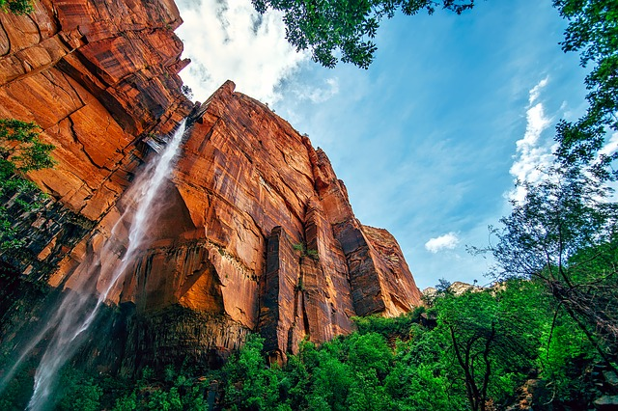If you love mother nature and like excursions, the outdoors and sports, visiting at least one of these incredible nature creations of the American continent should definitely be on your bucket-list! And if you have kids like us, then I bet they’ll love this.

2. Get lost in the streets of New York
The city of New York is everything that you expect… and more! Its vibrant feeling makes the “city that never sleeps” a must-visit in USA. Everything you’re looking for can be found here: art, museums, exhibitions, fashion, music, shops, etc…
3. Go on a road trip on Route 66
Who never dreamt about leaving everything behind, packing the essential items and hit the road? Driving through the United States is another must-do experience in which you’ll enjoy breathtaking views and find mythical cafes/restaurants/motels in the middle of nowhere that will teleport you into a classic film.
Route 66 is one of the most famous roads in the world if you’re thinking about a road trip. The route starts in Chicago where you can rent a car (Mustang or Cadillac will surely add extra points to this experience, but Cadillac if you have little hooligans with you) and travel all over the country until you reach Los Angeles.

4. What happens in Vegas, stays in Vegas
The “City of Sin” is worth a visit because its eccentricity makes it a very unique place in the world. You can easily feel the glamour by staying in one of its impressive casino hotels like the Venetian which has a replica of St. Mark’s Square inside and even canals with gondolas! 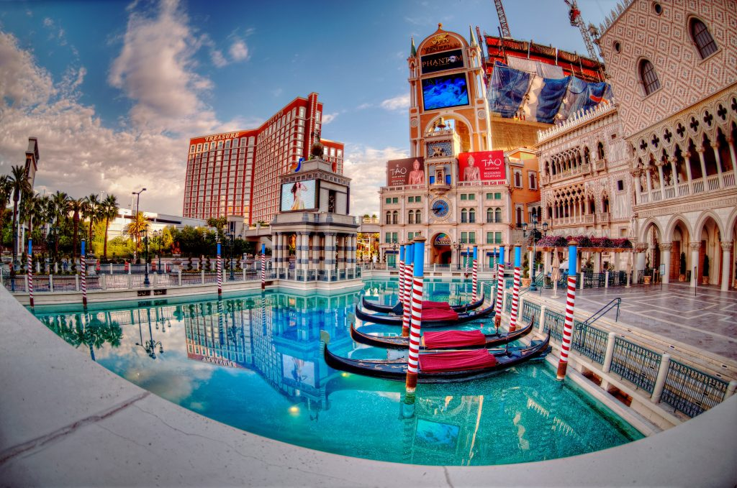 Alternatively you can bet a couple of tokens on the roulettes, BlackJack or the slot machines and cross your fingers… So leave your kids in the arcade arena in the Monte Carlo while you live every bachelors dream.
5. Cross the Golden Gate bridge
San Francisco is a city that is easy to fall in love with and it’s a bit different from other typical American cities. Visiting China Town, riding the famous cable cars or going to the popular Lombard Street are just some of the essential experiences that can’t be missed in this city. 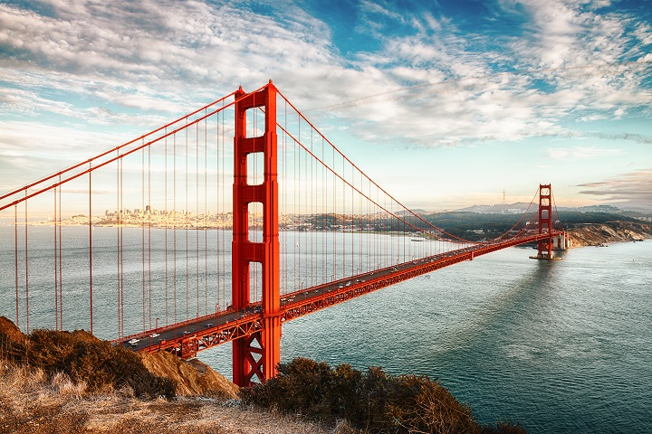 And crossing the glorious Golden Gate bridge from where you can enjoy spectacular panoramic views and also see the Alcatraz jail will make your stay in San Francisco even more memorable!

6. Cuddle with the stars in Hollywood
The Walk of Fame, the Dolby Theatre (previously known as Kodak Theatre), the palm trees and the classic Hollywood sign that watches the city from above are just some of the elements that make it worth visiting Hollywood. 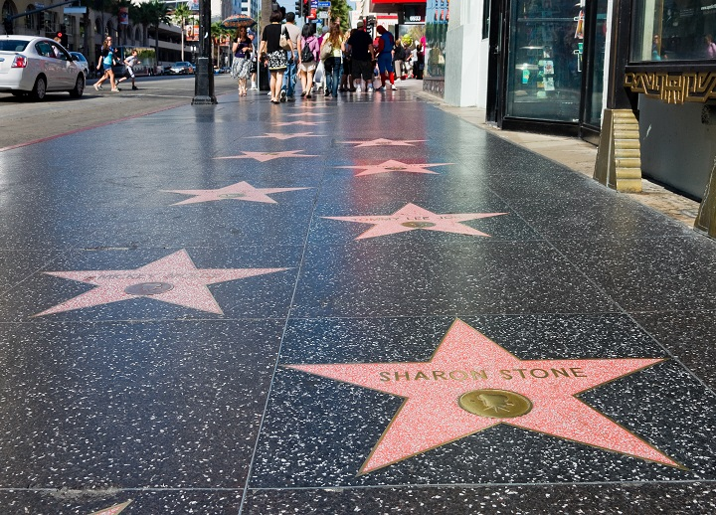We suggest walking along the streets and passing by the Walk of Fame so you can place your hands (or feet) on top of your favourite actor/actress/singer and let the city of Los Angeles make you dream big. I personally love Los Angeles for its calm yet busy life, the clash of nature and metropolitan that it so well fuses.

7. Go to a theme park and be a kid again
In the United States of America everything is big, and its theme parks aren’t an exception. The Disney factory has 4 theme parks and 2 water parks placed throughout the country. 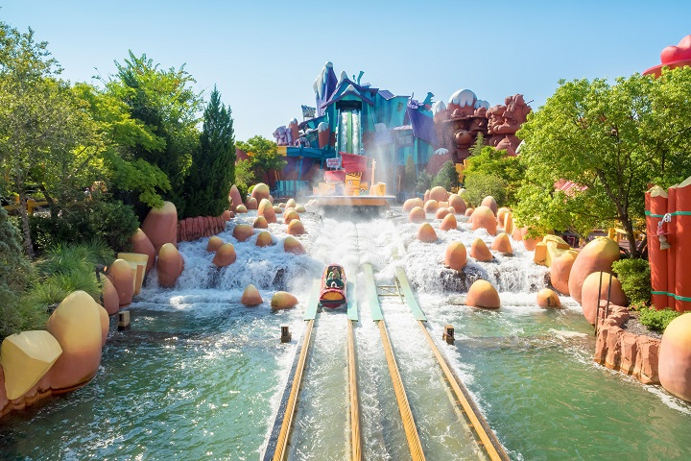Universal Studios also has theme parks with the most famous ones located in California and Orlando, where you can enjoy its breathtaking attractions and visit the sets of popular films and series! And don’t miss the Hogwarts attraction in Disney Land.

8. Visit the White House
A visit to the capital couldn’t be excluded from this list. The White House in Washington is an icon that has been the protagonist and has witnessed many key episodes of the American history.
Going on a tour of the White House, visiting the Capitol, admiring the Washington Monument, entering the Lincoln Memorial and imagining Martin Luther King performing his famous “I have a dream” speech make this visit to Washington a must-do experience!
9. Eat Desi In the States
It is a completely different feeling when you eat ghar ka Khanna in abroad. We loved the food in New York, but going to Sarvana Bhavan and sitting with a Dosa in the middle of New York is something surreal. Also try out the Indian food in Boston, they have nailed it!
As you would’ve probably guessed, we loved it! And all thanks to the team at alliance vacations for truly making this a vacation of a lifetime.
Akshay Bajpai and family, truly overwhelmed
Blog#3

Ok let me come straight to the point. I don't know how many of you have been to this place, butPachmarhi orPanchmadhi in Madhya Pradesh, India is a place one needs to visit atleast once, especially in the winters. It is a beautiful hillstation lapped in the Satpuda Mountain ranges. The temperatures here drop to about 3-4 degreeC in the winter, but it is worth getting cold in this natural scenic beauty. And the reason I say it is untouched is because the place is not filled up with tourists so much so that even moving around becomes difficult. Famous getaways near Mumbai include places like Alibaug, Matheran, Mahabaleshwar, Lonavala - Khandala and the likes, but they all suffer from the one dreaded thing -- Gross Commercialisation -- these places have been milked by tourists and tour operators to an extent that they are too crowded for people to enjoy the scenic beauty. Ok I cannot exactly call Pachmarhi a weekend getaway considering it takes you more than half a day to reach the foothills of this place and then another hour or so to be there. Your Journey can begin by first reaching a railway station called Pipariya which is located close to Pachmarhi. Or you can even consider coming in from Bhopal or Nagpur which connect to the hillstation.
Since, I have said even before that I would not tell you stuff like how i plan to spend my weekend and what I had for breakfast today, I would definitely suggest you on how to plan your weekend in Panchmarhi and what special delicacies to enjoy here. If you ever happen to be here, first of all, come with the intention of spending atleast 3 to 4 days, because Pachmarhi is worth every second of your visit and every penny you spend here. An ideal schedule could be landing here on a Friday and returning on Sunday.
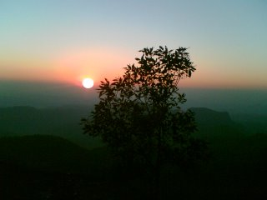
Places of interest can be easily obtained from a search on Google for Pachmarhi, so I would not spend my and your time on it. However, do not miss the Jatashankar caves and the Bee Falls. They are really cool. Also, the sunset at Dhoopgarh is worth a watch. It is common in Indian Tourist places to have a sunset or a sunset point with the same Sun setting behind the same old mountains. But, the Dhoopgarh sunset is something different, something like the one you would see at Ranikhet near Nainital in Uttaranchal without the snow-clad peaks. For starters enjoy the snap shown here.
If you are an animal lover, you can take a one day trip to the Satpuda Wildlife Sanctuary at Madhai, some 40 Km from Pipariya. Although you need to take special permissions to visit this protected land, it is worth a ride. The vast landmass has (on last count) 14 Tigers, a substantial figure considering the sorry state of wildlife protection plans in India. The 4 male, 6 female and 4 cub cat family is accompanied by a host of other animals and birds including Bisons, Deer, Sambhars, Neel Gaay, Peacocks, Huge Crocs, Oars or wild looking pigs as also the omnipresent monkeys and bundars. As for the road from Pipariya to Madhai, I bet you it is better than the best patches of road on the Mumbai-Pune Expressway!!! The road then takes a diversion and a 10-odd Km. patch of village road ( surrounded on both sides by lush-green fields, straight out of a Yashraj Film) leads you to the banks of Denva River, which you can cross by taking a motor-boat. Albeit, do not go there without a valid permit and no I wont tell you how to obtain it. And all my best wishes with you for sighting a tiger there!
So, the next time you have spare time and are thinking about a place where you can take your family along and enjoy a good mix of some new (Gupt Mahadev, Bee Fall, Jatashankar et al) and some similar (Pandav Caves, Apsara Vihar, etc.) looking places, book your tickets to Pachmarhi with Alliance Vacations and enjoy your time. A serene experience is waiting for you.
Manish Upadhyay, calmed and charged by the beautiful hill station

